**Thin Airfoil Analysis – The Panel Method Introduction**

The panel method is a method to arrive at an approximate solution for the forces acting on an object in general. Here it is based on inviscid flow analysis, so it is limited to the resultant pressure forces over the surface. This method is basically a numerical approximation that relies on using discrete elements with a prescribed flow potential for each element. The interaction of the elements are accounted for to satisfy the general boundary conditions – which here means that far from the surface the flow should revert to the mainstream velocity relative to the surface and at the surface the flow can not cross the element (acting as a solid surface). There are a number of books and papers written that describe the method in very general terms and even the inclusion of viscous forces to some degree. But here we are just introducing the method to get a feel for its usefulness in external flows, so we will use a simply geometry with a simply distribution of flow elements.

Since we are dealing with potential flow the Laplace of the velocity potential becomes the governing equation, . At a surface we have . Note that we can put our frame of reference on the surface so fluid flow approaches the surface.

Without deriving this it can be shown that the following defines the velocity potential at any point P in the flow field (using Green’s Identify):

where the integral is over the surface area of the flow, S, which says that to solve for the potential we evaluate the integral on the flow boundaries (both the solid surface and infinitely far away).

This comes from use of the divergence theorem that says:

where q is the velocity vector. This states that the rate of expansion within a volume equals the flux through the boundaries; if the fluid is incompressible then the left side is zero and the net flux through the boundary is zero (think of conservation of mass if that helps).

All this is nice but we really don’t need to find the potential of the entire flow, what our goal is, is to set up a flow that we know satisfies the velocity boundary condition at the surface (no velocity component across the surface) and far from the surface where the velocity is known. Since there are probably a lot of solutions to the flow that can achieve this we restrict the solution a little bit by forcing the Kutta condition on the surface (described later).

The general approach is to select a “grid” which is a series of “panels” that form the surface. Here we take the panels as straight flat surfaces arranged over the real surface, that in the limit of being very small panels resemble the actual surface. On each panel we place a distribution of flow elements (like sources, sinks vortices, etc) that when combined together will result in a flow field that will satisfy the surface boundary condition. There are lots of ways to identify which elements to use and how they may be distributed on the panels. Here we will use vortex elements, with one placed on each panel. The net flow is the result of superposition of the flow set up by each element. So at each point in the field we add together the flow caused by all of the panel elements. The panels that are far away will have less and less influence on the flow because the strength of the flow decreases with distance from the element origin. But the influence never really goes to zero.

So we put a series of panels over the surface and in doing so we need to specify the size of each panel. We place a vortex of some strength some where on the panel and now we must identify points on the surface where we want to make sure that the velocity is zero across the surface. So we are still using individual points to evaluate the element (vortex) flow field – in essence it needs its own origin to write an equation for the flow generated by this element. We also only pick a point on the panel to check to make sure that the net sum of contributions from all elements results in zero flow across the surface. This will be ok if the panels are reasonably small.

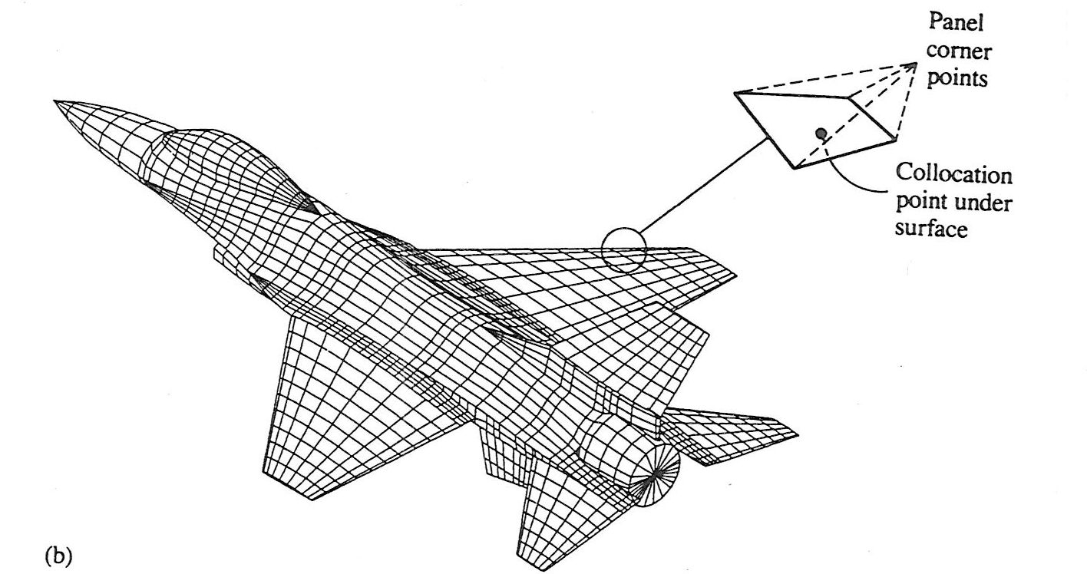

Fig. 1 Illustration of a panel geometry (Katz and Plotkin)

We define “collocation points” as the location on each panel where the velocity across the surface is to be zero. We also define element locations to be where individual elements (vortices) have their origins on the panel.

The method is going to solve for the needed vortex strength on each panel that keeps the velocity across all of the panels at zero. Once we have this distribution of strengths we will see that we can calculate the total lift on the surface that results from all of these elements. Recall that the lift experienced by a surface is really the component of the pressure at the surface integrated over the surface area in a direction normal to the approach velocity vector of the flow – it is not necessarily vertical, but usually related to the approach velocity.

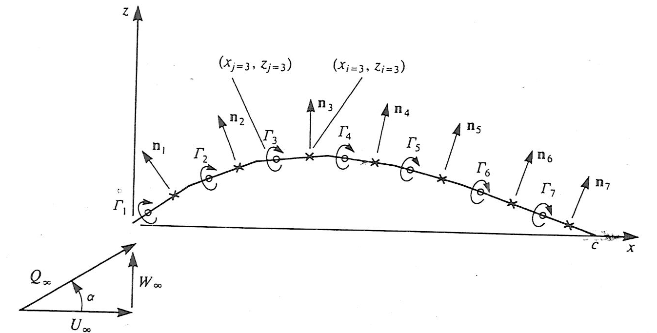

Fig. 2 Surface coordinates, (Katz and Plotkin)

Here we are going to use flat plate panels. So to get an idea of how we should define the vortex origins on each panel we can examine flow over a single flat plate at some angle of attack to the oncoming flow, .

First we define the “center of pressure”, xcp. This is the location on the surface where the resultant lift acts such that there is no net moment (see White Chapt. 8 for some details on this). In general, if the moment about the leading edge is Mo, L is the lift and x is the coordinate measured along the flat surface from the leading edge then:

*xcp = -Mo/L*.

Consider now flow over the same flat surface, the lift we have seen is *L= U (*note that we are going to define ** as positive clockwise – this is opposite to what we have done previously, but it helps get rid of some negative signs, this is not necessary, but convenient.

Now we have to apply a bit of flow theory to find out the value of *xcp*. Again, you can read White Chapt. 8 for details on this, here we present the results, since it is a bit messy. So first we assume that there is some distribution of vortex elements continually over the surface, such that there is a local circulation per unit length of surface, *(x*). The surface integral of this distribution results in the net total circulation: where “c” is the length of the flat surface, which we call the “chord”.

Now comes the Kutta condition. We want the flow to leave the surface flowing parallel with the back (trailing) edge. And if this is a surface like an airfoil we want both the top and bottom flows to leave smoothly from the trailing edge. For this to happen then we don’t expect there to be a pressure difference between the top and bottom of the surface at the trailing edge which would cause the flow to deflect up or down. If there is no pressure difference across the flow then the flow doesn't curve up or down, but flows straight and the local circulation at the trailing edge, (c), must be zero. So now we have a boundary condition for the integration of (x) to get the total circulation , that is  = 0 at x=c. The needed distribution was figured out for a single flat surface at an angle of attack of , the angle between the oncoming flow and the surface. It turns out the function that works is: . This is then integrated to get . So using this resultant expression for  and thereby getting the lift, *L,* and also using the above definition of *xcp* it turns out that the “center of pressure occurs at *xcp = c/4* . Remember this is where the moment is zero.

The lift force, *L*, is calculated as stated above, if we take that and divide by *1/2U2b*, where b is the span of the surface (in and out of the page) the result is an expression for the lift coefficient: *CL = 2sin  *

we take this result for a flat surface and vortex elements at the center of pressure for each flat element, which will be at a point ¼ of the distance along the panel from the beginning edge of the panel.

The next step is to find the location where we want to impose the condition of zero velocity crossing the surface. For this we are using a coordinate system that is (*x,z*) where *x* is again along the flat surface and *z* is normal to the surface. To find these points called collocation points, we note that the component of the velocity set up by a vortex element is:

where we have changed to Cartesian coordinates instead of cylindrical coordinates, where is at the center of pressure (where the vortex element is located). Also, *zo* in the above expression is going to be zero since it is on the surface. This equation comes from the velocity field that is set up for a single vortex, *q = -/2r*, and taking the component normal to the surface.

With *w* being the velocity normal to the surface set up by a vortex we need to add this to the velocity of the free flow (at angle of attack of   to the surface) and set the sum to equal zero: *w+ U sin  =0*. Using the above expression for *w*, setting *zo = 0* and *x0 = c/4* and *x= kc* (that is the position along the surface is *kc*, some fraction of *c*), the value of *k* can be found to be *k=3/4*. This says that the *x* location along the panel where the boundary condition is satisfied is at *x = 3c/4*, while the vortex is located at *xo = c/4.* Here “*c*” is the chord length of the individual panel.

So at this point image locating all of the panels on the surface. Each panel has its own angle of attack, . Each panel has a vortex element located at its own center of pressure and the normal velocity must be equal to zero at *x=3c/4* measured from the front of each panel. We can then write an equation for the zero velocity condition at a panel by taking the sum of all of the contributions from all of the panels, each with a different vortex strength **, and setting this sum to zero. This will result in N equations (one for each panel, N) with N unknowns of  for each panel. We can then solve for all ** using this set of equations.

Now we can set this up for a simple example to help pull all of this together, see the Fig. 3. We will use a thin flat surface representing a flat airfoil at an angle of attack of , with a uniform approaching flow of U. We will use two panels. I have defined the entire length to be “c”, NOT the length of each panel. Note that *x* and *z* used previously are along and normal to the surface, respectively, with *x* measured from the start of the panel. Now we shift things a bit to have a single coordinate system, we will use *x* measured from the leading edge of the entire surface, *z* is still normal to the surface.

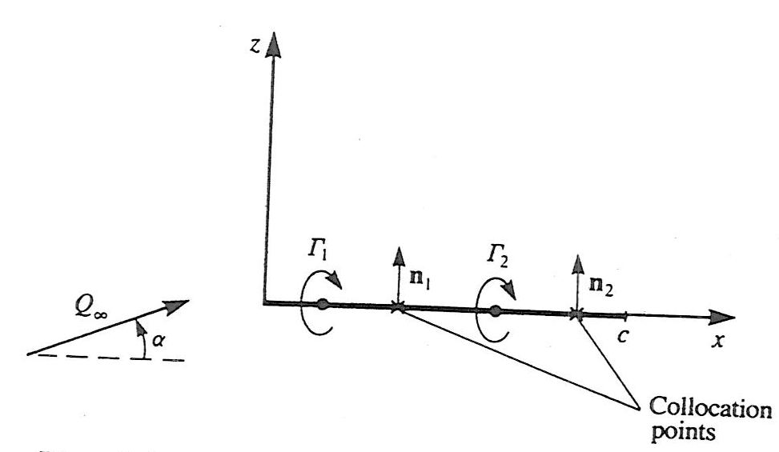

Fig. 3. Two panels along a flat surface of length c.

U

There are two vortex locations for our two panels: (c/8,0) and (5c/8,0)

The collocation points are: (3c/8,0) and (7c/8,0)

Note that the each of the outward normals, *ni*, points in the same direction in this case since both panels have the same orientation, but in general they could be at some angle , if the surface has a camber, that is it is not flat but a curved surface. The general equation for the boundary condition is:

The induced flow from each of the element needs to be added together to get the value of *q* in the above equation.

The general form for the velocity, *q*, at any point in the flow with a vortex element at (*xo,zo*) is gotten from above and written here as:

We can rewrite this as a matrix:

It is convenient to write this set of two equations for a “unit value” of **, that is **=1. Keep in mind that the flow caused by each vortex on the surface results only a component normal to the surface. We also are going to use values of *xo* and *x* based on the location of the vortices and collocation points, respectively. Consequently we can write the following velocity components except here these velocities assume **=1 in the above equations. The notation used below is that the first subscript, *i*, represents the collocation point of interest and the second subscript, *j*, identifies the vortex element that induces the velocity at the *i* collocation point.

We can define, again for **=1 for each panel with vortex *j*,:

We need to be careful here with this notation, *q* in the equation above is the velocity vector caused by the vorticies with the subscripts: *i* represents the collocation point and *j* the vortex location causing that flow. Also, the dot product with *ni* (the outward normal for each panel, gives the projection of *q* normal to the surface caused by vortex *j*. For example for the above example:

so *aij* are scalar quantities representing a measure of the velocity contribution from each vortex *j* at each collocation point *i* for a ** *j*value of 1 at each panel.

So now we want to find the velocities with some unknown distribution of *   *from all of the panels. We have a general equation for our two element surface for i=1,2:

so this expression for is set equal to the contribution from the free stream velocity: (again this is the component of U normal to the surface).

The final system of equations become:

Here the right hand side value of *U* is represented as the vector (*Ux,Uz*) indicating that *U* is a vector with *x* and *z* components. The components will be dependent of the orientation, or angle, of the panel. This set of equations can now provide the means to find all of the values of **, where the index represents each of the panel vortices. In the above example there are two values. From this solution we find the lift on each panel, *Li = Ui* and then the total lift as:

**Some further reading:**

Fluid Mechanics by F.M. White, Chapter 8

Low Speed Aerodynamics by Katz & Plotkin

Fundamentals of Aerodynamics by J.D. Anderson